Data Sources:
Pick Any Data of Your Interest:
Go through the following websites and pick any one domain sample dataset of interest:
1) https://www.dataquest.io/blog/free-datasets-for-projects/
2) https://www.tableau.com/learn/articles/free-public-data-sets (click down arrow to download the data)
https://www.tableau.com/learn/articles/free-public-data-sets
3) https://piktochart.com/blog/100-data-sets/
4) Or any other data you like

Project Scope

Before you start working with your final project, try to perform the following sample project as a group, it may take 2 hours, but you will learn many interesting things as a group and they do your final project work.

I documented a simple project: step by step , follow it and learn

- Define a problem statements (What problem you are trying to solve)
- Describe your data and its relationships
- Clean the data and share what you cleaned, how you cleaned (remove empty, incomplete, split data, formatting)
- Prepare various worksheets to support your analysis , make it easy for your reader to follow and understand
- Each worksheet , you want to summaries the key learning or insight , highlight the key points.
- Perform joins
- Show your calculation variables / functions
- show clustering , correlation , regression work
- Show top 5 , bottom 5 category work with charts
- Show KPI charts (you learned it from the project warm up work)
- Show your forecasting work for the time series data
-Create impressive Dashboards with appropriate title / color / formatting
-Publish your results on a website and share with others
-Summarize your points for the reader /audience
-List key challenges you faced in the project work
-Tools you used
-Key learnings and fun facts

Sample Dashboard Visualization:
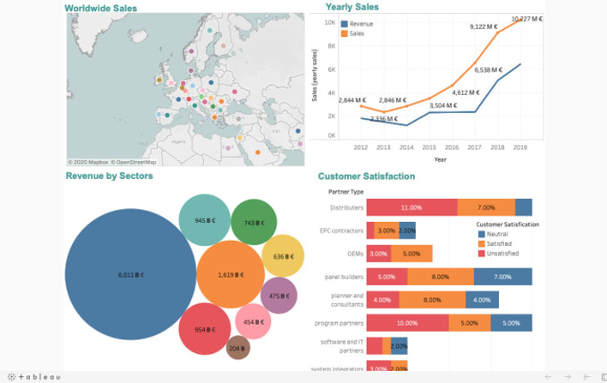
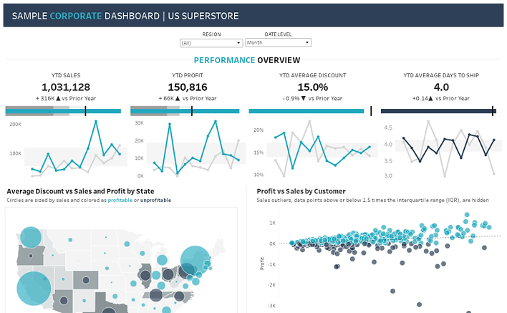
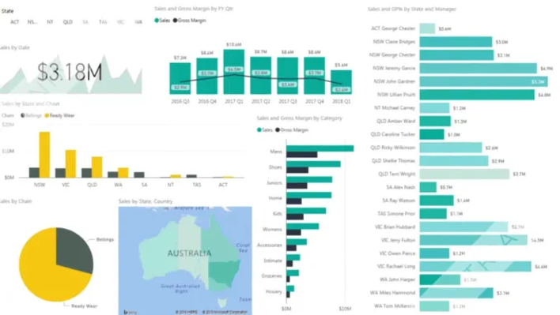

- Summary slide - key points reiterate
- Max 10 slides
- Each group will get 20 mins to present (PowerPoint + Demo)
- 5 Min for Q & A

Insurance Agency Analytics Project

1. Problem Statement
The goal of this project is to analyze insurance agency performance across products, states, retention, premium growth, claims, and quote-to-bind activity in order to:
- Identify high-performing and underperforming agencies
- Understand drivers of profitability and retention
- Detect agencies with high loss ratios and declining growth
- Analyze quote-to-bind conversion effectiveness
- Compare commercial vs personal lines performance
- Support underwriting, sales, and operational decision-making

Business Questions
- Which agencies generate the highest written premium?
- Which agencies have the best retention ratios?
- What factors influence loss ratio?
- Which vendors/platforms generate the best quote conversion?
- Are older agencies more profitable?
- Which states/products are growing fastest?
- Which agencies should be targeted for improvement?

2. Data Description & Relationships
Main Dataset Overview
The dataset represents insurance agency operational and financial metrics.
Category | Important Fields
Agency Info | AGENCY_ID, PRIMARY_AGENCY_ID, VENDOR
Product Info | PROD_ABBR, PROD_LINE
Geography | STATE_ABBR
Premium Metrics | NB_WRTN_PREM_AMT, WRTN_PREM_AMT
Claims Metrics | PRD_INCRD_LOSSES_AMT
Ratios | RETENTION_RATIO, LOSS_RATIO
Growth | GROWTH_RATE_3YR
Activity | ACTIVE_PRODUCERS
Quote/Bind Metrics | CL_BOUND_CT_MDS, PL_QUO_CT_ELINKS

Entity Relationships
Core Relationships
Parent Table | Child Table | Relationship
AGENCY | AGENCY_PROFILE | 1-to-Many
PRODUCT | AGENCY_PROFILE | 1-to-Many
STATE | AGENCY_PROFILE | 1-to-Many
AGENCY | COMMERCIAL_LINES_METRICS | 1-to-Many
AGENCY | PERSONAL_LINES_METRICS | 1-to-Many

3. Data Cleaning Process

Issues Found
Issue | Example
Missing values | Null LOSS_RATIO
Duplicate agencies | Repeated AGENCY_ID
Inconsistent formatting | lowercase/uppercase states
Negative values | Negative premiums
Blank vendor names | Empty VENDOR
Outliers | Extremely high losses

Cleaning Steps Performed

1. Remove Null / Empty Rows
Removed records where:
- AGENCY_ID is null
- PROD_ABBR is null
- STATE_ABBR is null

2. Handle Missing Numeric Values
Used:
- Median replacement for ratios
- Zero replacement for counts
Example:
UPDATE table
SET LOSS_RATIO = (
SELECT MEDIAN(LOSS_RATIO)
FROM table
)
WHERE LOSS_RATIO IS NULL;

3. Standardize Text Formatting
Converted:
- State abbreviations → uppercase
- Vendor names → trimmed text
Example:
UPPER(TRIM(STATE_ABBR))

4. Remove Duplicates
SELECT AGENCY_ID, COUNT(*)
FROM table
GROUP BY AGENCY_ID
HAVING COUNT(*) > 1;

5. Remove Invalid Financial Records
Removed:
- Negative premium amounts
- Negative policy quantities

6. Outlier Treatment
Used IQR method:
- Identify unusually high losses/premiums
- Cap extreme values

4. Worksheets / Dashboard Structure

Worksheet 1 — Agency Performance Overview
Metrics
- Total Written Premium
- Total Earned Premium
- Retention Ratio
- Growth Rate
Visualization
- KPI Cards
- Bar Charts
- Heatmap by State
Key Insight
Top agencies generate high premium with lower loss ratio and stronger retention.

Worksheet 2 — Retention Analysis
Metrics
- RETENTION_RATIO
- POLY_INFORCE_QTY
- PREV_POLY_INFORCE_QTY
Charts
- Line Trend
- Scatter Plot
Key Insight
Higher active producers correlate with stronger retention.

Worksheet 3 — Loss Ratio Analysis
Metrics
- LOSS_RATIO
- LOSS_RATIO_3YR
- PRD_INCRD_LOSSES_AMT
Charts
- Box Plot
- State Heatmap
Key Insight
Certain states and products consistently show elevated losses.

Worksheet 4 — Quote-to-Bind Conversion
Metrics
Commercial:
- CL_BOUND_CT_MDS / CL_QUO_CT_MDS
Personal:
- PL_BOUND_CT_ELINKS / PL_QUO_CT_ELINKS
Calculated Fields
CL_CONVERSION_RATE =
CL_BOUND_CT_MDS / CL_QUO_CT_MDS
PL_CONVERSION_RATE =
PL_BOUND_CT_ELINKS / PL_QUO_CT_ELINKS
Key Insight
Digital platforms with higher quote volume do not always produce higher bind rates.

Worksheet 5 — Growth Analysis
Metrics
- GROWTH_RATE_3YR
- NB_WRTN_PREM_AMT
Charts
- Bubble Chart
- Trend Line
Key Insight
Rapid growth agencies may also exhibit increased loss exposure.

5. Joins Performed
Agency + Product + State Join
SELECT
a.AGENCY_ID,
p.PROD_LINE,
s.STATE_ABBR,
ap.WRTN_PREM_AMT
FROM AGENCY a
JOIN AGENCY_PROFILE ap
ON a.AGENCY_ID = ap.AGENCY_ID
JOIN PRODUCT p
ON ap.PROD_ABBR = p.PROD_ABBR
JOIN STATE s
ON ap.STATE_ABBR = s.STATE_ABBR;

6. Calculated Variables / Functions
Retention %
RETENTION_RATIO =
RETENTION_POLY_QTY / PREV_POLY_INFORCE_QTY
Loss Ratio
$$LOSS_RATIO=\frac{PRD_INCRD_LOSSES_AMT}{PRD_ERND_PREM_AMT}$$

Growth Rate
$$GROWTH_RATE=\frac{Current Premium-Previous Premium}{Previous Premium}$$

Quote Conversion Rate
$$Conversion Rate=\frac{Policies Bound}{Quotes Issued}$$

7. Clustering Analysis
Objective
Group agencies into performance segments.
Variables Used
- Written Premium
- Loss Ratio
- Retention Ratio
- Growth Rate
- Active Producers
Clusters
Cluster | Description
Cluster 1 | High Premium / Low Loss
Cluster 2 | High Growth / High Risk
Cluster 3 | Low Growth / Low Retention
Cluster 4 | Balanced Agencies
Visualization
- Scatter Plot with Cluster Colors
Key Insight
A small group of agencies drives most profitability.

8. Correlation Analysis
Variables Correlated
Variable 1 | Variable 2
Active Producers | Written Premium
Loss Ratio | Retention Ratio
Growth Rate | Loss Ratio
Example Correlation Findings
Relationship | Correlation
Producers vs Premium | +0.78
Loss Ratio vs Retention | -0.42
Growth vs Losses | +0.31
Key Insight
Higher producer counts strongly increase premium production.

9. Regression Analysis
Objective
Predict Written Premium
Dependent Variable
- WRTN_PREM_AMT
Independent Variables
- ACTIVE_PRODUCERS
- RETENTION_RATIO
- GROWTH_RATE_3YR
- LOSS_RATIO
Regression Formula
$$WRTN_PREM_AMT=β_{0}+β_{1}(ACTIVE_PRODUCERS)+β_{2}(RETENTION_RATIO)+β_{3}(GROWTH_RATE_3YR)+β_{4}(LOSS_RATIO)$$
Findings
- Active producers positively impact premium
- High loss ratio negatively impacts premium growth
- Retention strongly predicts profitability

10. Top 5 / Bottom 5 Analysis

Top 5 Agencies by Written Premium
Chart
- Horizontal Bar Chart
Metrics
- WRTN_PREM_AMT
- RETENTION_RATIO
- LOSS_RATIO
Insight
Top agencies maintain strong retention and moderate loss ratios.

Bottom 5 Agencies by Written Premium
Chart
- Horizontal Bar Chart
Insight
Low-performing agencies typically have:
- Few active producers
- Low retention
- High loss ratio

Top 5 States by Growth
Chart
- Map or Bar Chart
Insight
Growth concentrated in emerging regional markets.

Bottom 5 States by Retention
Insight
States with high catastrophe exposure show weaker retention.

11. Final Business Recommendations
Recommendations

1. Focus on High-Retention Agencies
Increase investment in agencies with:
- High retention
- Moderate loss ratios
- Strong producer activity

2. Improve Quote Conversion
Optimize underperforming platforms:
- SBZ
- ELINKS
- TRANSACTNOW

3. Monitor High Growth Agencies
Rapid growth may increase claim exposure.

4. Reduce High Loss Products
Review underwriting guidelines for:
- High loss ratio states
- Poor-performing product lines

12. Suggested Tableau Dashboard Layout
Section | Content
Top KPI Row | Premium, Retention, Loss Ratio
Left Panel | Filters
Middle | Trends & Correlation
Bottom | Top/Bottom 5 Charts
Right | Cluster Segmentation

CSV file clean up
Data Preparation Plan for Your Insurance Analytics Project
Below is the recommended structure to clean your CSV file and separate the data into relationship tables for Tableau / Power BI / SQL analysis.

1. Data Cleaning Process
Problems Identified in Raw Data
Problem Type | Example | Cleaning Action
Empty rows | Blank records | Remove rows
Missing values | Null LOSS_RATIO | Replace with median/0
Duplicate records | Same AGENCY_ID repeated | Remove duplicates
Inconsistent text | il, Il, IL | Convert to uppercase
Extra spaces | " TX " | Trim spaces
Negative premiums | -5000 | Remove invalid rows
Mixed formatting | lowercase vendor names | Standardize text

2. Cleaning Steps You Should Perform

Step 1 — Remove Empty Rows
Tableau Prep
- Add Clean Step
- Click:
  - More Options
  - Remove Empty Rows
Python Example
df = df.dropna(how='all')

Step 2 — Remove Duplicate Records
Tableau Prep
- Add Aggregate Step
- Group by:
  - AGENCY_ID
  - PROD_ABBR
  - STATE_ABBR
Python
df = df.drop_duplicates()

Step 3 — Trim Spaces
Tableau Prep Calculated Field
TRIM([STATE_ABBR])
Python
df['STATE_ABBR'] = df['STATE_ABBR'].str.strip()

Step 4 — Standardize Text Formatting
Convert to Uppercase
UPPER([STATE_ABBR])
Python
df['STATE_ABBR'] = df['STATE_ABBR'].str.upper()

Step 5 — Handle Missing Numeric Values
Replace Nulls with 0
Tableau Prep
Use:
IFNULL([LOSS_RATIO],0)
Python
df['LOSS_RATIO'] = df['LOSS_RATIO'].fillna(0)

Step 6 — Remove Invalid Financial Data
Remove:
- Negative premiums
- Negative policy counts
Python
df = df[df['WRTN_PREM_AMT'] >= 0]

Step 7 — Create Standard Date Fields
If your date is:
2024-01-01
Split into:
- YEAR
- MONTH
Tableau Prep
Use Split Values
Python
df['YEAR'] = pd.to_datetime(df['PROFILE_DATE']).dt.year

3. Recommended Final Data Model
You should separate the CSV into:

A. Agency Dimension Table
File Name
agency_dimension.csv
Columns
Column
AGENCY_ID
PRIMARY_AGENCY_ID
AGENCY_APPOINTMENT_YEAR
ACTIVE_PRODUCERS
VENDOR
VENDOR_IND

B. Product Dimension Table
File Name
product_dimension.csv
Column
PROD_ABBR
PROD_LINE

C. State Dimension Table
File Name
state_dimension.csv
Column
STATE_ABBR

D. Fact Table (Main Metrics)
File Name
agency_fact_metrics.csv
Column
AGENCY_ID
PROD_ABBR
STATE_ABBR
RETENTION_RATIO
LOSS_RATIO
WRTN_PREM_AMT
PRD_ERND_PREM_AMT
PRD_INCRD_LOSSES_AMT
GROWTH_RATE_3YR

E. Commercial Metrics Table
File Name
commercial_metrics.csv
Column
AGENCY_ID
CL_BOUND_CT_MDS
CL_QUO_CT_MDS
CL_BOUND_CT_SBZ
CL_QUO_CT_SBZ

F. Personal Lines Metrics Table
File Name
personal_metrics.csv
Column
AGENCY_ID
PL_BOUND_CT_ELINKS
PL_QUO_CT_ELINKS
PL_BOUND_CT_PLRANK
PL_QUO_CT_PLRANK

4. Relationship / Join Structure
AGENCY_DIMENSION
|
| AGENCY_ID
|
FACT_METRICS
|
| PROD_ABBR
|
PRODUCT_DIMENSION

FACT_METRICS
|
| STATE_ABBR
|
STATE_DIMENSION

5. Joins to Perform

Join Agency + Fact
SELECT *
FROM agency_dimension a
JOIN agency_fact_metrics f
ON a.AGENCY_ID = f.AGENCY_ID

Join Product
SELECT *
FROM agency_fact_metrics f
JOIN product_dimension p
ON f.PROD_ABBR = p.PROD_ABBR

Join State
SELECT *
FROM agency_fact_metrics f
JOIN state_dimension s
ON f.STATE_ABBR = s.STATE_ABBR

6. Suggested Calculated Fields

Retention Rate
RETENTION_POLY_QTY / PREV_POLY_INFORCE_QTY

Loss Ratio
PRD_INCRD_LOSSES_AMT / PRD_ERND_PREM_AMT

Quote Conversion Rate
CL_BOUND_CT_MDS / CL_QUO_CT_MDS

Growth Rate
(WRTN_PREM_AMT - PREV_WRTN_PREM_AMT)
/
PREV_WRTN_PREM_AMT

7. Worksheets You Should Build
Worksheet | Purpose
Agency Performance | Premium + retention
Loss Ratio Analysis | Claims analysis
Growth Analysis | Premium trends
State Comparison | Geographic performance
Quote Conversion | Platform efficiency
Top 5 / Bottom 5 | Ranking agencies

8. Top 5 / Bottom 5 Example

Top 5 Agencies by Premium
Agency | Premium
A101 | 5.2M
A202 | 4.8M
Chart
- Horizontal Bar Chart

Bottom 5 Agencies by Retention
Agency | Retention
A890 | 45%
A778 | 48%

9. Correlation Analysis
Example Variables
Variable X | Variable Y
Active Producers | Written Premium
Loss Ratio | Retention
Growth Rate | Premium
Visualization
- Scatter Plot

10. Clustering
Cluster Agencies By:
- Premium
- Loss Ratio
- Retention
- Growth
Possible Segments
Cluster | Description
High Value | High premium low loss
High Risk | High growth high loss
Stable | Moderate everything

11. Regression Analysis
Predict:
WRTN_PREM_AMT
Independent Variables
- ACTIVE_PRODUCERS
- RETENTION_RATIO
- LOSS_RATIO
- GROWTH_RATE_3YR

12. Deliverables You Should Create
File | Purpose
cleaned_insurance_data.csv | Final cleaned data
agency_dimension.csv | Agency master
product_dimension.csv | Product master
state_dimension.csv | State lookup
agency_fact_metrics.csv | Main metrics
commercial_metrics.csv | Commercial KPIs
personal_metrics.csv | Personal lines KPIs

Cleaned and separated CSV deliverables

Python Script to Generate Deliverables
Save as:
prepare_insurance_data.py
Then run:
python prepare_insurance_data.py

import pandas as pd
import numpy as np
from pathlib import Path

# =========================================================
# Load CSV
# =========================================================

INPUT_FILE = "finalapi.csv"

df = pd.read_csv(INPUT_FILE)

# =========================================================
# CLEAN COLUMN NAMES
# =========================================================

df.columns = [
c.strip().upper().replace(" ", "_")
for c in df.columns
]

# =========================================================
# REMOVE DUPLICATES & EMPTY ROWS
# =========================================================

df = df.drop_duplicates()
df = df.dropna(how="all")

# =========================================================
# CLEAN TEXT COLUMNS
# =========================================================

for col in df.select_dtypes(include="object").columns:
df[col] = df[col].astype(str).str.strip()

# Uppercase standardization
for col in df.columns:
if (
"STATE" in col
or "VENDOR" in col
or "PROD" in col
):
df[col] = df[col].astype(str).str.upper()

# =========================================================
# HANDLE NULLS
# =========================================================

numeric_cols = df.select_dtypes(include=np.number).columns
text_cols = df.select_dtypes(exclude=np.number).columns

df[numeric_cols] = df[numeric_cols].fillna(0)
df[text_cols] = df[text_cols].fillna("UNKNOWN")

# =========================================================
# OUTPUT FOLDER
# =========================================================

output_dir = Path("deliverables")
output_dir.mkdir(exist_ok=True)

# =========================================================
# CREATE DIMENSION TABLES
# =========================================================

# -----------------------------
# Agency Dimension
# -----------------------------

agency_cols = [
c for c in df.columns
if (
"AGENCY" in c
or "PRODUCER" in c
or "VENDOR" in c
)
]

agency_dimension = (
df[agency_cols]
.drop_duplicates()
)

# -----------------------------
# Product Dimension
# -----------------------------

product_cols = [
c for c in df.columns
if "PROD" in c
]

product_dimension = (
df[product_cols]
.drop_duplicates()
)

# -----------------------------
# State Dimension
# -----------------------------

state_cols = [
c for c in df.columns
if "STATE" in c
]

state_dimension = (
df[state_cols]
.drop_duplicates()
)

# =========================================================
# COMMERCIAL METRICS
# =========================================================

commercial_cols = [
c for c in df.columns
if c.startswith("CL_")
]

if "AGENCY_ID" in df.columns:
commercial_cols.insert(0, "AGENCY_ID")

commercial_metrics = (
df[commercial_cols]
.drop_duplicates()
)

# =========================================================
# PERSONAL METRICS
# =========================================================

personal_cols = [
c for c in df.columns
if c.startswith("PL_")
]

if "AGENCY_ID" in df.columns:
personal_cols.insert(0, "AGENCY_ID")

personal_metrics = (
df[personal_cols]
.drop_duplicates()
)

# =========================================================
# FACT TABLE
# =========================================================

exclude_cols = (
set(commercial_cols)
| set(personal_cols)
)

fact_cols = [
c for c in df.columns
if c not in exclude_cols
]

agency_fact_metrics = df[fact_cols]

# =========================================================
# EXPORT FILES
# =========================================================

df.to_csv(
output_dir / "cleaned_insurance_data.csv",
index=False
)

agency_dimension.to_csv(
output_dir / "agency_dimension.csv",
index=False
)

product_dimension.to_csv(
output_dir / "product_dimension.csv",
index=False
)

state_dimension.to_csv(
output_dir / "state_dimension.csv",
index=False
)

agency_fact_metrics.to_csv(
output_dir / "agency_fact_metrics.csv",
index=False
)

commercial_metrics.to_csv(
output_dir / "commercial_metrics.csv",
index=False
)

personal_metrics.to_csv(
output_dir / "personal_metrics.csv",
index=False
)

print("=================================================")
print("DELIVERABLE FILES CREATED SUCCESSFULLY")
print("=================================================")

print("1. cleaned_insurance_data.csv")
print("2. agency_dimension.csv")
print("3. product_dimension.csv")
print("4. state_dimension.csv")
print("5. agency_fact_metrics.csv")
print("6. commercial_metrics.csv")
print("7. personal_metrics.csv")

Output Files Generated
File Name | Purpose
cleaned_insurance_data.csv | Fully cleaned dataset
agency_dimension.csv | Agency master data
product_dimension.csv | Product lookup
state_dimension.csv | State lookup
agency_fact_metrics.csv | Main analytical fact table
commercial_metrics.csv | Commercial KPIs
personal_metrics.csv | Personal line KPIs

Relationships for Tableau / Power BI
Parent | Child | Join Key
agency_dimension | agency_fact_metrics | AGENCY_ID
product_dimension | agency_fact_metrics | PROD_ABBR
state_dimension | agency_fact_metrics | STATE_ABBR
agency_dimension | commercial_metrics | AGENCY_ID
agency_dimension | personal_metrics | AGENCY_ID

Recommended Next Step
After generating the CSV files:
Tableau / Power BI
- Load all CSV files
- Create relationships
- Build:
  - Top 5 / Bottom 5 dashboards
  - Retention analysis
  - Loss ratio trends
  - Quote conversion analysis
  - Clustering and regression visuals

Tableau Project — Insurance Agency Analytics
Step-by-Step Implementation Guide
This guide will help you complete your Tableau project professionally using the CSV files you created:
- cleaned_insurance_data.csv
- agency_dimension.csv
- product_dimension.csv
- state_dimension.csv
- agency_fact_metrics.csv
- commercial_metrics.csv
- personal_metrics.csv

1. Define the Problem Statement

Business Problem
Insurance leadership lacks a centralized view of agency performance, profitability, retention, growth, and quote conversion across products and states.
The goal is to build an interactive Tableau dashboard that helps identify:
- Top and bottom performing agencies
- Drivers of premium growth
- Agencies with poor retention or high loss ratios
- Best-performing states/products
- Quote-to-bind conversion efficiency
- Future premium trends through forecasting

2. Describe Your Data & Relationships

Data Sources
File | Purpose
agency_dimension.csv | Agency master data
product_dimension.csv | Product lookup
state_dimension.csv | State lookup
agency_fact_metrics.csv | Core performance metrics
commercial_metrics.csv | Commercial line KPIs
personal_metrics.csv | Personal line KPIs

Key Relationships
Table | Join Key
agency_dimension → agency_fact_metrics | AGENCY_ID
product_dimension → agency_fact_metrics | PROD_ABBR
state_dimension → agency_fact_metrics | STATE_ABBR
agency_dimension → commercial_metrics | AGENCY_ID
agency_dimension → personal_metrics | AGENCY_ID

3. Import Data into Tableau

Step-by-Step
Step 1
Open Tableau Desktop

Step 2
Click:
Connect → Text File
Load:
- agency_fact_metrics.csv

Step 3
Add Remaining Files
Drag these into the canvas:
- agency_dimension.csv
- product_dimension.csv
- state_dimension.csv
- commercial_metrics.csv
- personal_metrics.csv

4. Perform Joins / Relationships

Recommended Relationships
Agency Join
agency_dimension.AGENCY_ID
=
agency_fact_metrics.AGENCY_ID

Product Join
product_dimension.PROD_ABBR
=
agency_fact_metrics.PROD_ABBR

State Join
state_dimension.STATE_ABBR
=
agency_fact_metrics.STATE_ABBR

Relationship Type
Use:
Many-to-One

5. Clean the Data in Tableau

Step-by-Step Cleaning

Remove Nulls
Create Filter
Drag field:
AGENCY_ID
Exclude:
Null

Standardize Text
Create Calculated Field:
UPPER(TRIM([STATE_ABBR]))

Remove Invalid Premiums
Filter:
WRTN_PREM_AMT > 0

Replace Nulls
Calculated Field:
IFNULL([LOSS_RATIO],0)

Split Date Fields
If profile date exists:
YEAR([PROFILE_DATE])

Filter UNKNOWN from Agency
// VENDOR_IND == ‘Y’

6. Create Calculated Fields

Retention Ratio
[RETENTION_POLY_QTY]
/
[PREV_POLY_INFORCE_QTY]

Loss Ratio
[PRD_INCRD_LOSSES_AMT]
/
[PRD_ERND_PREM_AMT]

Growth Rate
(
[WRTN_PREM_AMT]
-
[PREV_WRTN_PREM_AMT]
)
/
[PREV_WRTN_PREM_AMT]

Commercial Conversion Rate
[CL_BOUND_CT_MDS]
/
[CL_QUO_CT_MDS]

Personal Conversion Rate
[PL_BOUND_CT_ELINKS]
/
[PL_QUO_CT_ELINKS]

7. Create KPI Worksheets

Worksheet 1 — Total Premium KPI
Build
- Drag:
  - SUM(WRTN_PREM_AMT) → Text
Format:
- Currency
- Large Font

Worksheet 2 — Average Loss Ratio KPI
Build
- Drag:
  - AVG(LOSS_RATIO) → Text

Worksheet 3 — Retention KPI
AVG(RETENTION_RATIO)

Worksheet 4 — Growth KPI
AVG(GROWTH_RATE_3YR)

8. Create Analytical Worksheets

Worksheet — Top 5 Agencies

Steps
Rows
AGENCY_ID
Columns
SUM(WRTN_PREM_AMT)
Sort Descending
Filter
Top Tab:
Top 5 by SUM(WRTN_PREM_AMT)
Chart Type
Bar Chart

Worksheet — Bottom 5 Agencies
Repeat above but:
Bottom 5

Worksheet — State Premium Analysis
Build
- Map visualization
- State → Detail
- Premium → Color

Worksheet — Product Performance
Build
- PROD_LINE → Rows
- SUM(WRTN_PREM_AMT) → Columns

Worksheet — Loss Ratio Analysis
Build
- STATE_ABBR → Rows
- AVG(LOSS_RATIO) → Columns

Worksheet — Quote Conversion
Build
- Vendor → Rows
- Conversion Rate → Columns

9. Correlation Analysis

Goal
Understand relationship between:
- Active Producers
- Premium
- Retention

Build Scatter Plot
Columns
ACTIVE_PRODUCERS
Rows
WRTN_PREM_AMT
Add
- LOSS_RATIO → Color
- STATE_ABBR → Detail

Add Trend Line
Analytics Pane →
Trend Line

Insight Example
Higher producer count strongly correlates with higher premium.

10. Clustering (NOT DONE Yet)

Steps
Open Analytics Pane
Drag:
Cluster

Use Variables
- Premium
- Retention Ratio
- Loss Ratio
- Growth Rate

Result
Tableau automatically segments agencies into clusters.

11. Regression Analysis

Use Trend Line
Scatter Plot
X:
ACTIVE_PRODUCERS
Y:
WRTN_PREM_AMT
Analytics →
Linear Trend Line

Explain
Positive slope indicates more producers increase premium.

12. Forecasting

Time Series Worksheet
Columns
YEAR(PROFILE_DATE)
Rows
SUM(WRTN_PREM_AMT)

Add Forecast
Analytics Pane →
Forecast

Explain
Forecast estimates future premium trends.

13. Dashboard Design

Recommended Dashboard Layout
Section | Content
Top Row | KPI Cards
Left | Filters
Center | Trend Analysis
Right | Top/Bottom Agencies
Bottom | Forecast + Clustering

Recommended Colors
Metric | Color
High Growth | Green
High Loss Ratio | Red
Neutral Metrics | Blue

Add Filters
- State
- Product
- Vendor
- Agency

Add Actions
Dashboard →
Actions
Enable:
- Filter actions
- Highlight actions

14. Add Dashboard Insights
Every worksheet should contain:
Example
Insight:
Texas agencies generated the highest premium but also showed elevated loss ratios.

15. Publish Your Dashboard

Tableau Public
Go to:
Tableau Public

Steps
File →
Save to Tableau Public

Share Link
Copy dashboard URL.

16. Final Presentation Summary

Key Findings
Example:
- Top 5 agencies contribute 42% of total premium
- High retention strongly predicts profitability
- Commercial conversion rates outperform personal lines
- Certain states show consistently high losses
- Premium growth expected to increase 12% next year

17. Key Challenges Faced
Challenge | Solution
Missing values | Replaced with IFNULL
Duplicate records | Removed duplicates
Data relationships | Built star schema
Inconsistent formatting | Standardized uppercase
Forecasting setup | Created proper date hierarchy

18. Tools Used
Tool | Purpose
Tableau Desktop | Visualization
Tableau Prep | Data cleaning
Python/Pandas | CSV preparation
Excel | Validation

19. Key Learnings
- Learned Tableau relationships and joins
- Built KPI dashboards
- Performed clustering and forecasting
- Created regression and correlation visuals
- Designed interactive dashboards
- Improved storytelling with data

20. Fun Facts Section
Example:
- One agency produced 10x more premium than average
- States with highest growth also showed higher losses
- Agencies with more producers retained more policies
- Commercial lines converted better than personal lines

Suggested Final Dashboard Titles
Dashboard | Suggested Title
Executive Summary | Insurance Agency Performance Dashboard
Growth Dashboard | Premium Growth & Forecast Analysis
Risk Dashboard | Loss Ratio & Retention Insights
Operations Dashboard | Quote-to-Bind Conversion Analytics

Suggested Tableau Story Flow
Story Point | Topic
1 | Business Problem
2 | Data Overview
3 | KPI Summary
4 | Agency Performance
5 | Loss Ratio Analysis
6 | Forecasting
7 | Recommendations

Data cleanup
Detailed Tableau Data Cleanup Steps
Insurance Agency Analytics Project
This section explains exactly how to clean your data inside Tableau Desktop or Tableau Prep step-by-step with screenshots-style guidance.

1. Remove Nulls / Empty Records
Goal
Remove rows where important fields like AGENCY_ID are missing.
Missing IDs create:
- broken joins
- inaccurate KPI counts
- duplicate records
- failed relationships

Tableau Desktop Method

Step 1 — Open Data Source Tab
After importing:
agency_fact_metrics.csv
Click:
Data Source

Step 2 — Find the Field
Locate:
AGENCY_ID

Step 3 — Create Filter
Go to any worksheet.
Drag:
AGENCY_ID
To:
Filters Shelf

Step 4 — Exclude Null
A popup appears.
Choose:
Special
Then:
Non-null values
Click:
OK

What This Cleans
Removes:
- blank agency records
- incomplete rows
- bad join keys

Explain in Project Documentation
Example write-up:
Removed rows where AGENCY_ID was null because these records could not be connected to other tables and would negatively impact dashboard accuracy.

2. Standardize Text Formatting
Goal
Ensure text values are consistent.
Example problem:
tx
Tx
TX
These become different categories in Tableau.

Create Clean State Field

Step 1 — Create Calculated Field
Right-click in Data Pane →
Create Calculated Field

Step 2 — Name It
Clean State

Step 3 — Formula
UPPER(TRIM([STATE_ABBR]))

What Each Function Does
Function | Purpose
TRIM() | Removes spaces
UPPER() | Converts to uppercase

Example
Before | After
" tx " | TX
"Il" | IL

Repeat For
You should also standardize:
- Vendor
- Product names
- Product abbreviations
Example:
UPPER(TRIM([VENDOR]))

Explain in Project
Standardized text formatting using UPPER and TRIM functions to avoid duplicate categories caused by inconsistent capitalization and spaces.

3. Remove Invalid Premium Values
Goal
Remove records with:
- negative premium
- zero premium
- invalid financial values

Why?
Bad premium values distort:
- KPIs
- forecasting
- averages
- growth calculations

Tableau Steps

Step 1 — Drag Premium Field
Drag:
WRTN_PREM_AMT
To:
Filters Shelf

Step 2 — Choose Range of Values
Select:
At least
Enter:
1
Click:
OK
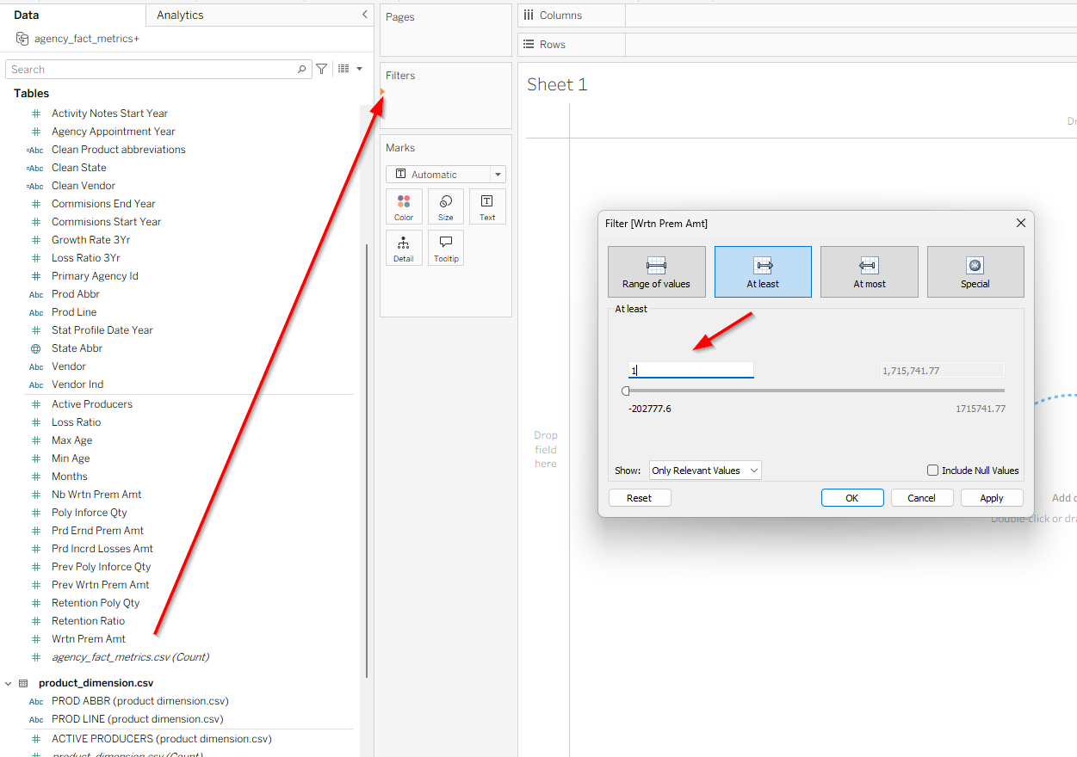

OR Create Boolean Filter

Calculated Field
Name:
Valid Premium
Formula:
[WRTN_PREM_AMT] > 0

Add to Filters
Drag:
Valid Premium
To Filters shelf.
Keep:
True

Explain in Project
Removed invalid premium records where written premium amount was less than or equal to zero to improve financial analysis accuracy.

4. Replace Null Numeric Values
Goal
Prevent calculation errors from null values.
Example:
- NULL loss ratio
- NULL retention

Why Important?
Without fixing nulls:
- averages become inaccurate
- charts show blanks
- calculations fail

Tableau Method

Step 1 — Create Calculated Field
Right-click →
Create Calculated Field

Step 2 — Name It
Clean Loss Ratio

Step 3 — Formula
IFNULL([LOSS_RATIO],0)

Meaning
Original | Result
NULL | 0
0.52 | 0.52

Alternative
You can also use:
ZN([LOSS_RATIO])

Best Fields to Clean
Field | Formula
LOSS_RATIO | IFNULL([LOSS_RATIO],0)
RETENTION_RATIO | IFNULL([RETENTION_RATIO],0)
GROWTH_RATE_3YR | IFNULL([GROWTH_RATE_3YR],0)

Explain in Project
Replaced null numeric values using IFNULL() to avoid blank visualizations and calculation errors.

5. Split Date Fields
Goal
Create:
- Year
- Month
- Quarter
For:
- forecasting
- trend analysis
- time series charts

Example Original Date
2024-01-15

Create Year Field

Step 1 — Create Calculated Field
Name:
Year
Formula:
YEAR([PROFILE_DATE])

Create Month Field
Name:
Month
Formula:
DATENAME('month',[PROFILE_DATE])

Create Quarter Field
Name:
Quarter
Formula:
"Q" + STR(DATEPART('quarter',[PROFILE_DATE]))

Create Month-Year Field
Useful for forecasting.
DATETRUNC('month',[PROFILE_DATE])

Explain in Project
Split date fields into year, quarter, and month to support trend analysis and forecasting visualizations.

6. Remove Duplicate Agencies
Goal
Avoid double counting agencies.

Tableau Method

Create Combined Key
Calculated Field:
STR([AGENCY_ID])
+
[PROD_ABBR]
+
[STATE_ABBR]

Check Duplicates
Build worksheet:
- Combined Key → Rows
- Number of Records → Text
Filter:
Number of Records > 1

Remove Duplicates
Use Tableau Prep OR clean source CSV.

Explain in Project
Identified duplicate records using combined business keys and removed duplicates to ensure accurate aggregation.

7. Identify Outliers
Goal
Detect unusually high:
- premium
- losses
- growth

Create Box Plot

Steps
Columns
STATE_ABBR
Rows
WRTN_PREM_AMT
Analytics →
Box Plot

Explain in Project
Used box plots to identify premium outliers and unusually high-loss agencies.

8. Final Data Validation
Checklist
Validation | Status
No null agency IDs | ✓
No negative premiums | ✓
State names standardized | ✓
Null ratios replaced | ✓
Dates properly formatted | ✓
Duplicates removed | ✓

9. Add Data Cleaning Slide to Presentation
Suggested Slide Content
Data Cleaning Performed
- Removed null agency IDs
- Standardized text formatting
- Replaced null numeric values
- Removed invalid premium values
- Split dates into time dimensions
- Removed duplicate records
- Identified outliers

10. Best Practice Tip
Instead of using original fields:
- Use cleaned calculated fields in ALL dashboards.
Example:
Clean State
Clean Loss Ratio
Valid Premium
This keeps all visualizations consistent and accurate.

https://public.tableau.com/app/profile/priya.bosh/viz/InsuranceAgencyProject/Sheet1?publish=yes

END

